**Experiment – 1.2**

**Student Name: Yash Gupta           UID: 20BCS5009**

**Branch: CSE                                     Section: 706 - B**

**Subject Name: Computer Networks Lab**

**Subject Code: 20CSP-257**

**1. Aim:**

Implement all the networking commands and show their working output.

**2. REQUIREMENTS:** COMMAND PROMPT

**3. STEPS:**

OPEN CMD AS ADMINISTRATOR AND TYPE THESE COMMAND FOR  OUTPUTS:

1. Ping

2. Ipconfig

3. Tracert

4. Nslookup

5. Netstat

6. Arp

7. Hostname

#### PING: The ping command is used to test connectivity between two hosts.

#### COMMAND: ping google.com

#### OUTPUT:

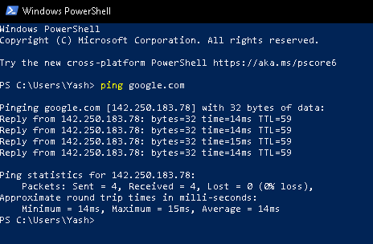

1. *IPCONFIG: This command displays all current  TCP/IPnetwork configuration values and refreshes.*

*Dynamic Host Configuration Protocol (DHCP) and Domain NameSystem (DNS) settings*

#### COMMAND: ipconfig

#### OUTPUT:

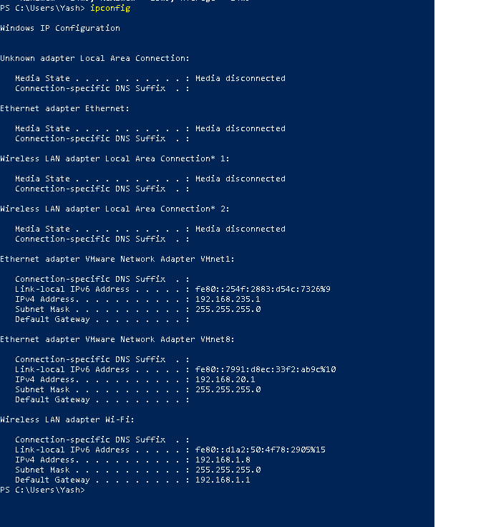

* + - 1. *TRACERT: This command is used to diagnose path-related problems.*

*COMMAND: tracert www.google.co.in*

*OUTPUT:*

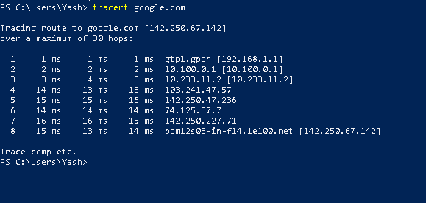

* + - 1. *NSLOOKUP: NSLookup is a great utility for diagnosingDNS name resolution problems. Just type the NSLookup command,*

*and Windows will display the name and IP address of the device’s default DNS server.*

*COMMAND: nslookup*

*OUTPUT:*

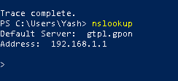

1. *NETSTAT: This command displays active connections, ports on which the computer is listening, Ethernet statistics, the IP routing table,*

*and IP statistics.*

*COMMAND: netstat*

*OUTPUT:*

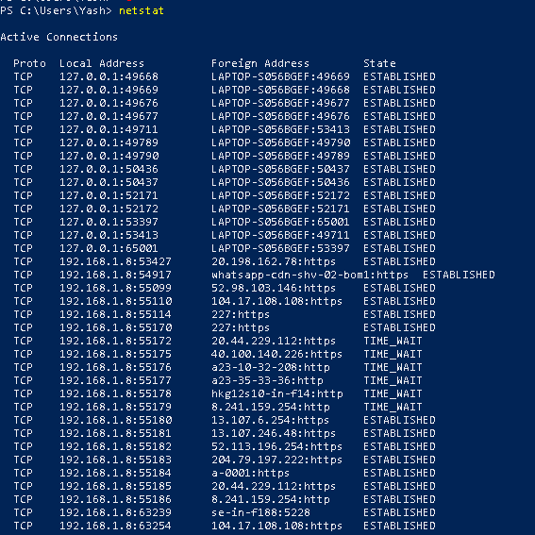

1. *ARP: The ARP command corresponds to the Address Resolution Protocol. Although it is easy to think of network communications in terms of IP addressing, packet delivery is ultimately dependent on the Media Access Control (MAC) address of the device’s networkadapter.*

*COMMAND: Arp -a*

*OUTPUT:*

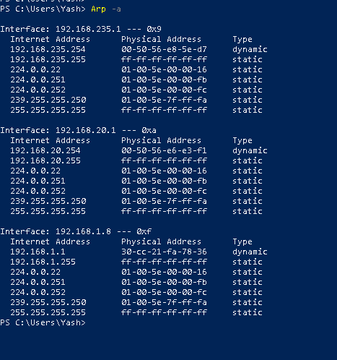

1. HOSTNAME: Typing Hostname at the command promptreturns the local computer name.

COMMAND: hostname

OUTPUT:

